





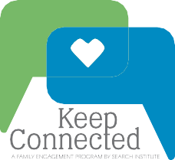


PRESENTS

Keep Connected
A Family Engagement Series

Kent Pekel, Ed.D. President and CEO Search Institute
Keep Connected Facilitator

