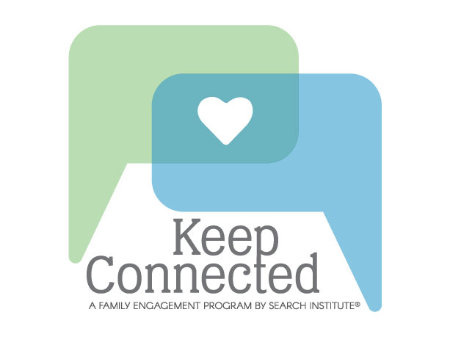
MIDDLE SCHOOL PARENTS:
Keep Connected Through
Big Changes

Keep Connected is designed to strengthen family engagement, learn keys to positive family relationships and try new ways to stay connected as kids grow up. It is for families of teens and pre-teens between the ages of 10 to 14.

Many programs look at what's wrong with families. Keep Connected starts with a family's strengths to build on what they're already doing right.

The Keep Connected Workshops include time for:

• Parents to explore challenges and strategies with each other
• Youth to explore family relationships with other youth
• Parents and youth to explore their relationships together
• Strategies and tools to connect and build trust with their families

Who:

Where:

When:

For More Information:
Keep Connected was developed by Search Institute, a national research organization

